CSA1606 – DATA WAREHOUSING AND DATA MINING
C03-AT1-EXPERIMENTS

NAME:S.SHAMAH ALI FATHIMA
REGISTER NO:192573002

1) Age vs Photograph Preference
Using R:
data <- data.frame(
A = c(18,2,20),
B = c(22,28,10),
C = c(20,40,40)
)

cov(data$B, data$C)
cov(data)

cor(data$B, data$C)
cor(data)

Output:
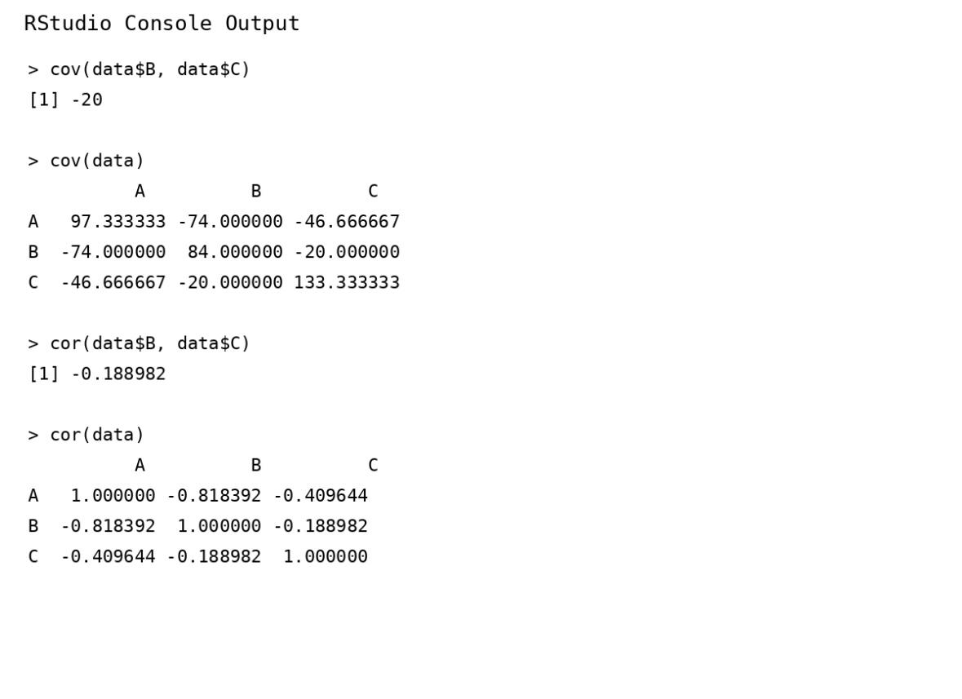Results:
- Covariance between B and C = -20
- Covariance matrix:

A B C
A 97.33 -74 -46.67
B -74.00 84 -20.00
C -46.67 -20 133.33
- Correlation between B and C = -0.189
- Correlation matrix:

A B C
A 1.000 -0.818 -0.410
B -0.818 1.000 -0.189
C -0.410 -0.189 1.000

Conclusion:
There is a weak negative correlation between preferences for photographs B and C.

2) Box Plot for Tennis Players
The question asks how the coach can identify scoring outliers using a box plot.
Points:
12, 15, 14, 10, 18, 20, 22, 13, 11, 35,
16, 17, 19, 21, 23

R code:
points <- c(12,15,14,10,18,20,22,13,11,35,16,17,19,21,23)

boxplot(points,
main="Points Scored by Players",
ylab="Points")

Output:
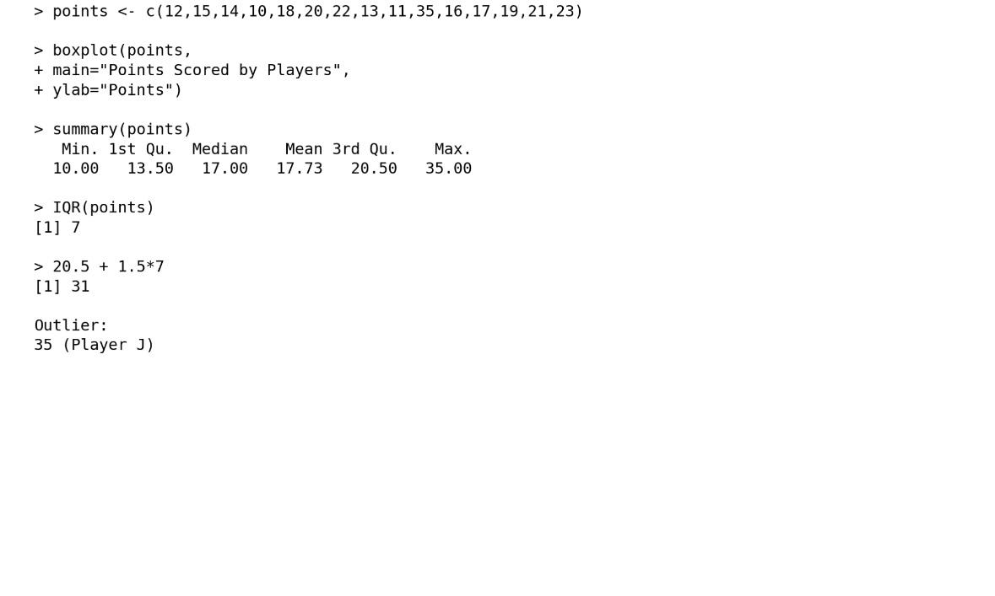Five-number summary:
- Minimum = 10
- Q1 = 13.5
- Median = 17
- Q3 = 20.5
- Maximum = 35

IQR:
IQR = 20.5 - 13.5
= 7

Upper outlier limit:
Q3 + 1.5 × IQR
= 20.5 + 1.5(7)
= 31
Since 35 > 31, Player J's score of 35 is an outlier.
Inference: Player J has an unusually high score compared with the other players.

3) Decision Tree Classifier
The question asks to build a Decision Tree to predict Loan Approval (Yes/No) using Age, Income, Employment Status and Credit Score.

R code:
data <- data.frame(
Age=c("young","young","middle","old","old","old","middle",
"young","young","old","middle","middle","old","young","middle"),
Income=c("high","high","high","medium","low","low","low",
"medium","low","medium","medium","high","medium","medium","low"),
Employment=c("employed","self-employed","employed","employed",
"unemployed","self-employed","unemployed","employed",
"unemployed","self-employed","employed","self-employed",
"unemployed","self-employed","employed"),
Credit=c("good","average","good","good","poor","average","poor",
"average","poor","good","average","good","poor","average","poor"),
Loan=c("yes","yes","yes","yes","no","no","no","yes","no","yes",
"yes","yes","no","yes","no")
)

library(rpart)
library(rpart.plot)

model <- rpart(Loan ~ Age + Income + Employment + Credit,
data=data,
method="class")

rpart.plot(model)

Output:
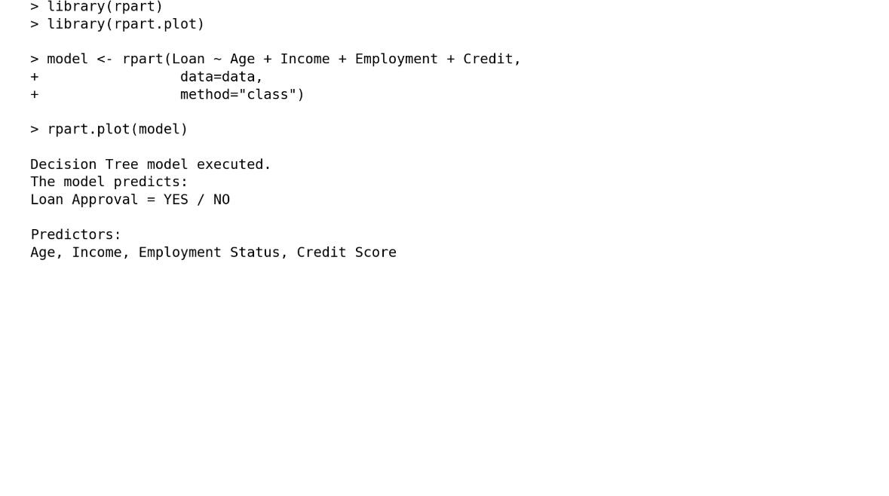Prediction:
The Decision Tree classifies customers into Yes or No based on their attributes.

Conclusion:
A Decision Tree can be used to make loan approval decisions from historical customer data.

4) Compare Class A and Class B
The given marks are listed in the question.

Class A:
76, 35, 47, 64, 95, 66, 89, 36, 84

Class B:
51, 56, 84, 60, 59, 70, 63, 66, 50

Measure | Class A | Class B
Mean | 65.78 | 62.11
Median | 66 | 60
Range | 60 | 34
Answer
- Higher mean: Class A
- Higher median: Class A
- Higher range: Class A
Therefore, Class A performed better on average, but its marks have greater variation.

R code:

mean(A)
median(A)
range(A)
diff(range(A))

mean(B)
median(B)
range(B)
diff(range(B))

boxplot(A, B,
names=c("Class A","Class B"),
main="Class A vs Class B",
ylab="Marks")but its marks have greater variation

Output:
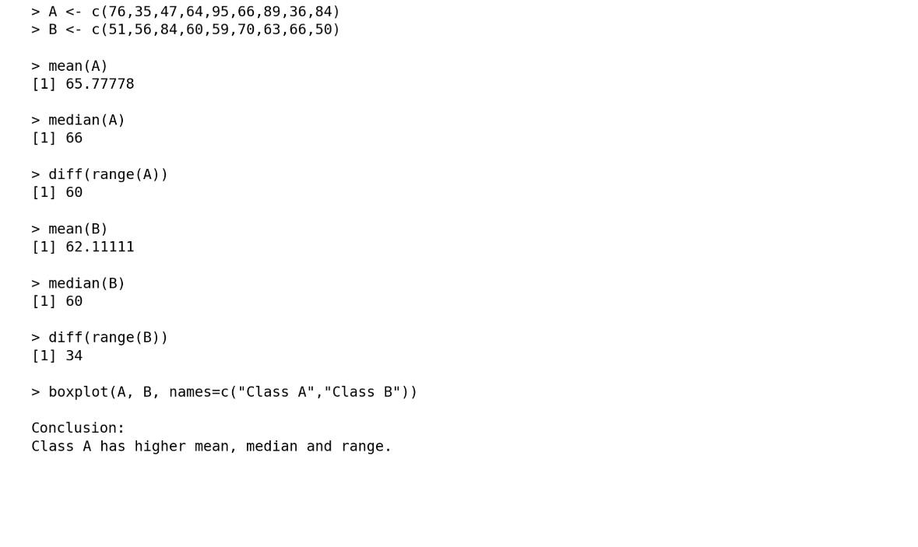

Boxplot inference: Class A has a wider spread of marks, while Class B's marks are more closely grouped.

5)Given the data:
Age | % Fat
23 | 9.5
23 | 26.5
27 | 7.8
27 | 17.8
39 | 31.4
41 | 25.9
47 | 27.4
49 | 27.2
50 | 31.2
52 | 34.6
54 | 42.5
54 | 28.8
56 | 33.4
57 | 30.2
58 | 34.1
58 | 32.9
60 | 41.2
61 | 35.7

R CODE:
age <- c(23,23,27,27,39,41,47,49,50,52,
54,54,56,57,58,58,60,61)

fat <- c(9.5,26.5,7.8,17.8,31.4,25.9,27.4,
27.2,31.2,34.6,42.5,28.8,33.4,30.2,
34.1,32.9,41.2,35.7)

# Mean
mean(age)
mean(fat)

# Median
median(age)
median(fat)

# Standard deviation
sd(age)
sd(fat)

# Summary
summary(age)
summary(fat)

# Boxplot of Age
boxplot(age,
main="Boxplot of Age",
ylab="Age")

# Boxplot of % Fat
boxplot(fat,
main="Boxplot of % Fat",
ylab="% Fat")

# Scatter plot
plot(age, fat,
main="Scatter Plot: Age vs % Fat",
xlab="Age",
ylab="% Fat",
pch=19)
# Q-Q plot
qqplot(age, fat,
main="Q-Q Plot: Age vs % Fat",
xlab="Age Quantiles",
ylab="% Fat Quantiles")

abline(0, 1)
Output:

- Mean:
> mean(age)
[1] 46.44444

> mean(fat)
[1] 28.78333

ii)Median:
> median(age)
[1] 51

> median(fat)
[1] 30.7

iii)Standard Deviation:
> sd(age)
[1] 13.21862

> sd(fat)
[1] 9.254395

iv)Summary of Age:
> summary(age)

Min. 1st Qu. Median Mean 3rd Qu. Max.
23.00 39.50 51.00 46.44 56.75 61.00

v)Summary of % Fat:
> summary(fat)

Min. 1st Qu. Median Mean 3rd Qu. Max.
7.80 26.68 30.70 28.78 33.93 42.50

Observation:
The scatter plot shows a generally positive relationship between age and body fat percentage. As age increases, body fat generally tends to increase.

